Tuesdays with Morrie 93-112 discussion
1. What type of figurative language is this (from the first paragraph): “The white rain gutter hung like a lid over the doorway.”
2. Read back through the first few pages (93-93). What evidence can we see that Morrie’s body is deteriorating?
3. Re-read page 96 and summarize Morrie’s feeling about emotions and how to experience them.
4. What animal does Morrie want to be reincarnated as, and why? Check page 100 if you’re unsure. It shows an interesting character trait about Morrie.
5. What was Morrie’s experience at the mental hospital like? See pages 100-102 for details and evidence.
6. What specific character traits can you tell about Morrie based on the following passage?
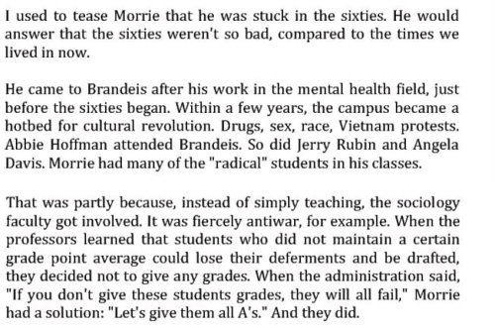
7. How about this passage?
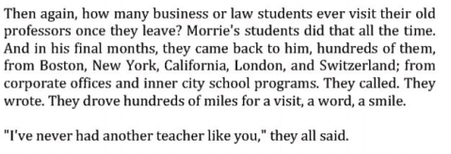
8. What did you learn from all the allusions to the Vietnam War during the section about Morrie’s time teaching college in the ‘60s?

