Tuesdays with Morrie 75-92 discussion

Characterization (indirect/direct, round/flat, static/dynamic, traits, motivations)
Allusions
Context clues

1. In the first few paragraphs, we see an allusion to O.J. Simpson. How do you think Morrie felt about the Simpson trial based on what you know about his character?
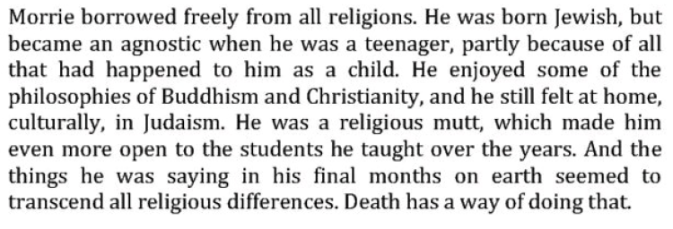
2. What character traits do you see in Morrie here?
3. List three of Morrie’s motivations in seeing Mitch every week.
4. Discuss Morrie’s main aphorism from this chapter: “Learn how to die and you learn how to live.”
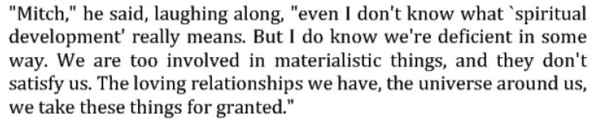
5. Use context clues to determine the meaning of “deficient” and “materialistic.”
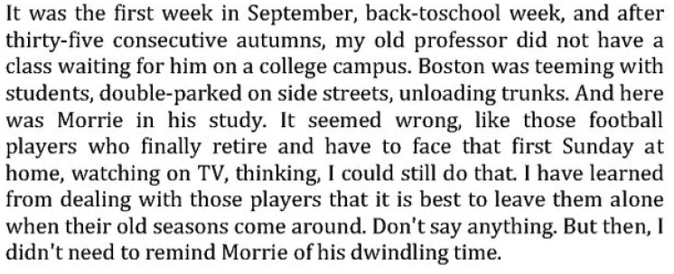
6. What type of figurative language does Mitch here, and what two things is he comparing?
7. Morrie talks about the importance of family and brings up Mitch’s family—specifically, his brother. Why does Mitch change the subject? What does this tell you about him?

