Tuesdays with Morrie 59-73 review – Barringer
1. Why did Mitch want to record his conversations with Morrie?
2. What did Morrie want to tell Mitch about on the tapes?
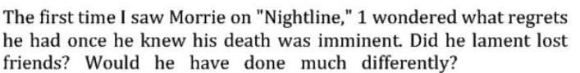
3. Use context clues to determine the meaning of both “imminent” and “lament.”
4. What was Mitch’s senior thesis about in college?
5. What was Morrie’s health like during the first Koppel interview vs. the second one?
6. Describe Morrie’s father and mother, as well as what his childhood was like. Look at 69-70 if you’re not sure.
7. Describe Morrie’s stepmom and what effect she had on Morrie.
8.

