Tuesdays with Morrie 32-45 review – Barringer

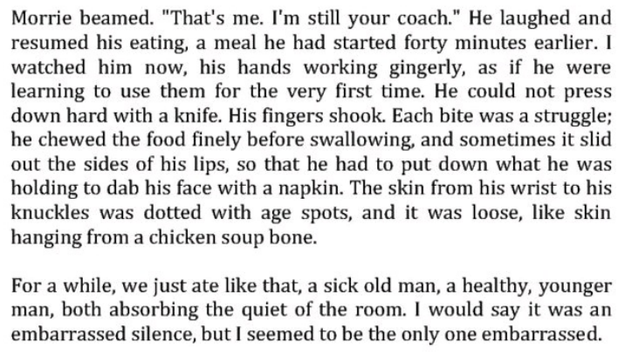
1. What’s the effect of this contrast between Morrie and Mitch?
2. Relate this passage to the idea that youth is wasted on the young.
3. Discuss round/flat characters. Are Morrie and Mitch round or flat?
4. Discuss static/dynamic characters. Are Morrie and Mitch static or dynamic?
5. Discuss protagonists/antagonists. What are Morrie and Mitch? Who or what are our antagonists?
6. What are the types of conflict? Which do we see present in this story so far?
7. What test did Morrie’s doctor give him to see how much breath he still has in his lungs?
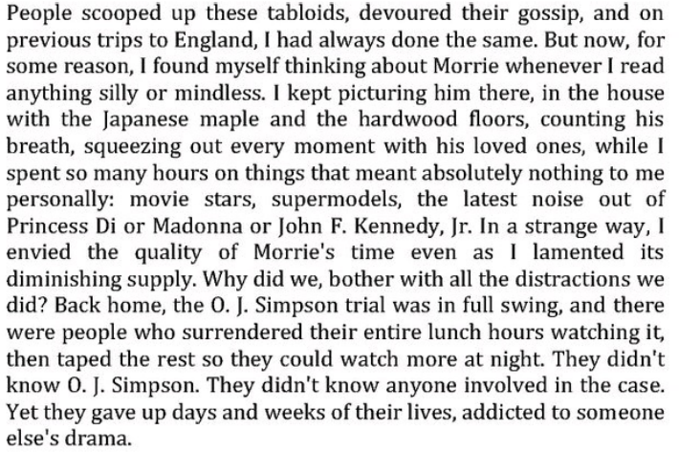
8. Discuss this passage. Do you agree with Morrie? He says, “The culture we have doesn’t make people feel good about themselves. And you have to be strong enough to say if the culture doesn’t work, don’t buy it.
9. What happened to Mitch’s job and what was he able to do with his extra time?

