Tuesdays with Morrie 129-144 discussion
1. Why do you think Mitch didn’t mention his wife until this late in the novel? It was a specific choice on his part.
2. Is Mitch’s wife round or flat? Cite examples.
3. Is Mitch’s wife dynamic or static? Cite examples.
4. Explain whether this passage shows Mitch will be a dynamic character:
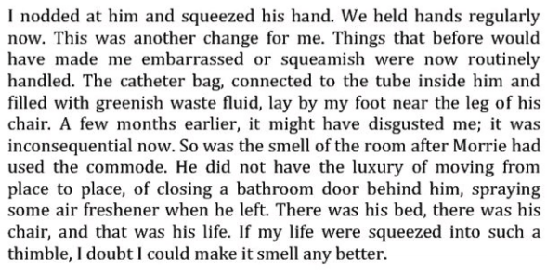
5. Use context clues to determine the meaning of “shortsightedness.”
