Tuesdays with Morrie 113-128 discussion
1. What does Morrie think about material items, wealth, and power? See the beginning of the chapter. Find explicit evidence to back up your point.
2. What’s better than money and things?
3. How do these lessons relate to Mitch and the lifestyle he lives?
4. Use context clues to determine the meaning of the phrase “on the contrary”:
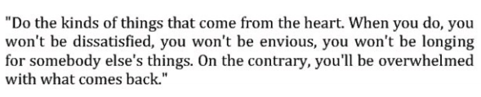
5. Re-read this paragraph. Why did the author choose to place this paragraph at the beginning of the chapter? What purpose does it serve?
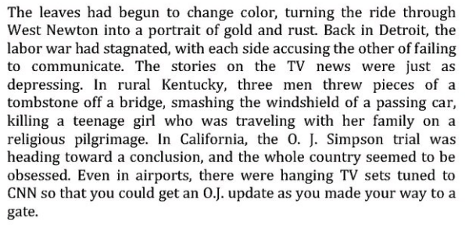
6. What changes has Morrie’s body undergone lately? Are these the types of changes that make someone a dynamic character?
7. What was Morrie’s philosophy about being “fully present”?
8. Morrie makes up lots of aphorisms such as, “If you’re in bed, you’re dead.” What others can you think of from the book or from real life?
9. Re-read the bottom of 125 through 127. What direct and indirect characterization do we get about Morrie’s father? Is he a round or flat character?

